MODULE 04

MODAL VERBS
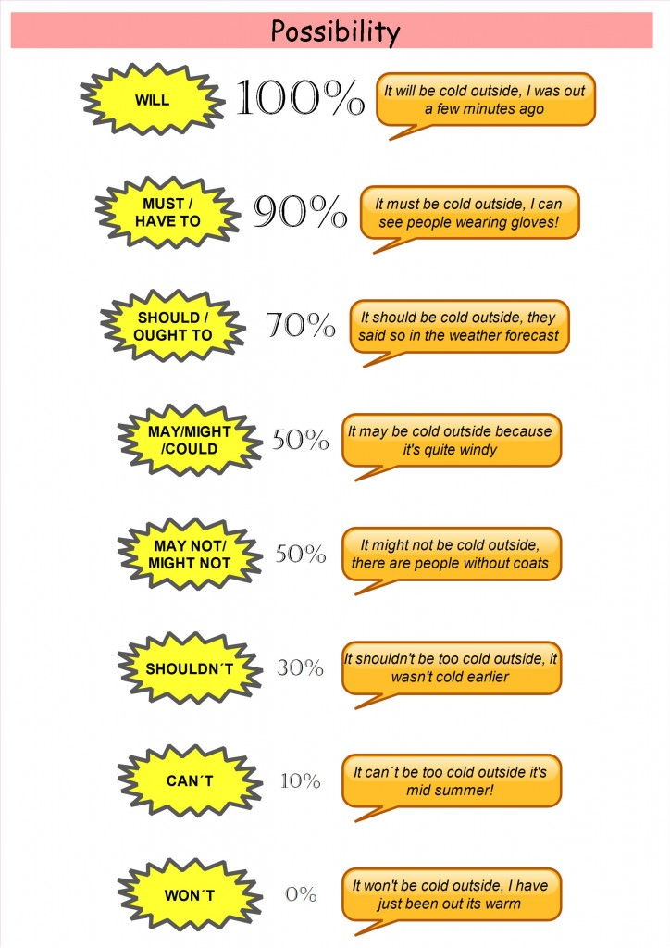

Modal verbs
We use modal verbs to show if we believe something is certain, probable or possible (or not). We also use modals to do things like talking about ability, asking permission making requests and offers, and so on.
The modal verbs are:

Modal | USES | Present / Future | PAST
be supposed to | expectation | We are supposed to meet them | We were supposed to meet them.
be to | strong expectation | We are to meet them here. | We were to meet them here.
can / could  Can - Can't  Could | ability / possibility  informal permission  informal polite request  impossibility (negative only) | I can learn modal verbs in the class.  You can use my car tomorrow.  Can I borrow your book?  Cats can't swim. | I could jump high a few years ago but now I can't.
have to | necessity  lack of necessity (negative) | I have to go to the English class today.  I don't have to go to the class today. | I had to go to the English class yesterday.  I didn't have to go to the class yesterday.
have got to | necessity | I have got to go to the class today | I had to go to the class yesterday.
had better | strongly advised | You had better be on time. | (past form uncommon)
may | polite request  formal permission  less than 50% certainty | May I borrow your book?  You may leave the room.  He may be at the university. | He may have been at the university.
Might | less than 50% certainty | He might be at the university. | He might have been at the university.
must | strong necessity  prohibition  95% certainty | I must go to the class today.  You must not open that door.  Mary isn't in class. She must be sick.(present only) | I had to go to the class yesterday.  Mary must have been sick yesterday.
ought to | advisability  80% certainty | I ought to study tonight.  She ought to be at school | I ought to have studied last night.  She ought to have done well on the test.
shall | ask another person's opinion (only used with I or we) | Shall I invite them too?  Shall we dance?
should | advisability  80% certainty | I should study tonight  He should be at school | You should have paid your bills.  He should have done well on the test.

Legal Obligation / Official | MUST | Police officer: 'You must wear a seatbelt.'
Logical Conclusion | MUST | The teacher's absent. She must be sick.
Reporting a Rule | BE SUPPOSED TO | We are supposed to turn our cell phones off in movie theaters.
Personal Necessity / Obligation | HAVE TO / HAVE GOT TO | I have to call the doctor today.
Possibility | CAN | I can meet with you on Friday.
Ability | CAN / BE ABLE TO | I can play the piano.  I am able to speak English.
Permission | CAN / BE ALLOWED TO | I can have a dog in my apartment. I am allowed to have pets in my room.
Past Ability | COULD / WAS ABLE TO | When I was a kid, I could run for hours.  could vs was were able to
Past Permission | WAS ALLOWED / PERMITTED TO | I wasn't allowed to go out at nights.
Advice | SHOULD | You should call your mother on her birthday.
Warning | HAD BETTER | You'd better study before the test.
A Choice / Not required | DON'T HAVE TO | I don't have to wear a suit to work.
Possibility / Uncertainty about the future  *adverb MAYBE | MAY / MIGHT | It might / may rain this evening.  May be it will rain this evening.
Polite request | WOULD / COULD | Would you open the door, please?
Permission | MAY / CAN / COULD | May I borrow your pen?
To express what you want | WOULD LIKE | I would like to learn English free.
Preference | WOULD RATHER | I would rather walk than drive.

How certain am I?
Positive 100% Negative
Must Can’t
Might Must not
May Might not
Could May not
Less certain
The impersonal passive is used in scientific writing.
Passive voice for Present/Future Modals
“CAN, MAY, MIGHT, SHOULD, MUST, OUGHT TO”
Passive Constructions in scientific writing
Modals- Passive voice(Present /future)  Can  (by us) – this part is optional and it is omitted in scientific writing | Auxiliary verb “be” is added.  Can + be + V3  Active voice: We can separate the Bunsen burner into five parts.  Passive voice: The Bunsen burner can be separated into five parts.  Negative: The Bunsen burner cannot be separated into five parts.  Question: Can the Bunsen burner be separated into five parts?
May | May + be + V3  Active voice: We may heat a piece of copper gauze in a Bunsen flame.  Passive voice : A piece of copper gauze may be heated in a Bunsen flame.  Negative: A piece of copper gauze may not be heated in a Bunsen flame.  Question: May a piece of copper gauze be heated in a Bunsen flame?
Might | Might + be + V3  Active voice: They might mix a liquid into the boiling tube.  Passive voice: A liquid might be mixed into the boiling tube.  Negative: A liquid might not be mixed into the boiling tube.  Question: Might a liquid be mixed into the boiling tube?
Should | Should + be + V3  Active voice: We should place a small amount of the compound in a dry clean ignition tube.  Passive voice: A small amount of the compound should be placed in a dry clean ignition tube.  Negative: A small amount of the compound should not be placed in a dry clean ignition tube  Question: Should a small amount of the compound be placed in a dry clean ignition tube?
Must | Must + be + V3  Active voice: We must allow water to come into contact with sodium.  Passive voice: Water must be allowed to come into contact with sodium.  Negative: Water must not be allowed to come into contact with sodium.  Question: Must water be allowed to come into contact with sodium?
Ought to | Ought to +be + v3  Active voice: They ought to use this chemical in their practical examination.  Passive voice: This chemical ought to be used by them in their practical examination.  Negative: This chemical ought not to be used by them in their practical examination  Question: Ought this chemical to be used by them in their practical examination?

Rewrite these sentences in passive voice.
- An electric arc produces the heat required for welding.

- We should pour a liquid into a set of communicating vessels
…………………………………………………………………………………
- We can remove the can from the flame.
…………………………………………………………………………………
- We must change a solid into a liquid by heating.
……………………………………………………………………………….
- We ought to stir the contents of the boiling tube with a glass rod.
…………………………………………………………………………………
- We must grip the tube firmly with a pair of tongs.
…………………………………………………………………………………
- Squirrels may pollinate the flowers of canopy trees.
…………………………………………………………………………………
- They might place the tube in a beaker of boiling water.
………………………………………………………………………………..
- We can warm the tube warmly.
………………………………………………………………………………..
- Sex pheromones attract only the male of the same species.
…………………………………………………………………………………..
- We should heat the mixture.
………………………………………………………………………………….
- The filter paper should cover the entire perforated area of the plate.
…………………………………………………………………………………
- We must remove the beaker from the freezing mixture.
…………………………………………………………………………………
- You should never move any object that is burning.
…………………………………………………………………………………
Pair work
Rewrite the following passage using the correct form of the verb in brackets.
Substances (consist of) small parts, or particles, which (know) as molecules. Molecules (compose of) atoms. Some substances, like salt and water for example, (has) molecules which (can, analyze) further into other substances. If a molecule of water (analyze), for example, it (find, consist of) two atoms of hydrogen and one atom of oxygen. Substances whose molecules (compose of) atoms of other substances (know) as compounds. Other substances (have) molecules which (can, break down) into atoms of other substances, and these (call) elements. Hydrogen and oxygen for example (be) elements. Thus if a molecule of Oxygen (analyze) it (find, consist of) only atoms of oxygen and not of any other substance. There (be) 92 natural elements. Some (be) metallic solids like copper, iron and lead; some (be) non-metallic solids like sulphur and carbon; and some (be) gases like oxygen, hydrogen and nitrogen.
Substances are consisted of…………………………
Try to guess the meaning of the words that are highlighted.

Give instructions to be followed at a laboratory
Give instructions to be followed at a field visit.
Give instructions to be followed at the Public Library.

